(300) | SERIAL C0109

TRANSPORT INDUSTRY ⎯ CONCRETE HAULAGE CONTRACT DETERMINATION

INDUSTRIAL RELATIONS COMMISSION OF NEW SOUTH WALES

Application by Ausgroup Consulting.

(No. IRC 3305 of 2000)

Before the Honourable Mr Justice Peterson | 14 July 2000

VARIATION

1. Delete Schedule B of Annexure A - Pioneer Concrete (NSW) Pty Limited Enterprise Agreement of the said Contract Determination published 30 November 1990 (260 I.G. 608) as varied and insert in lieu thereof the following:

SCHEDULE B - REVIEW OF CARTAGE RATES RISE AND FALL
Date effective from 1 July 2000

NB: Where the costs of any individual item, group sub total or total of the costs listed in this Schedule and/or the basis used to establish the utilisation rate varies by an amount of 5 per cent or more at any of the half-yearly reviews, then the utilisation rate will be amended accordingly. If the variation is less than 5 per cent, then the benchmarks will not move, nor will the rate.

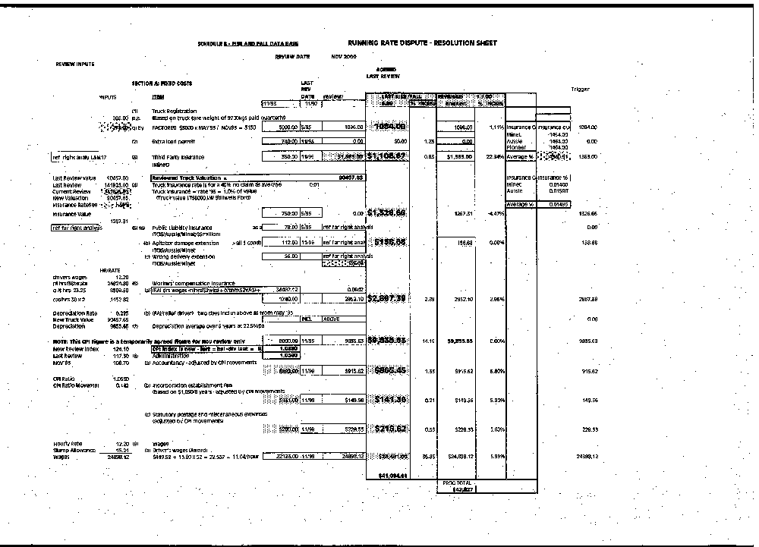
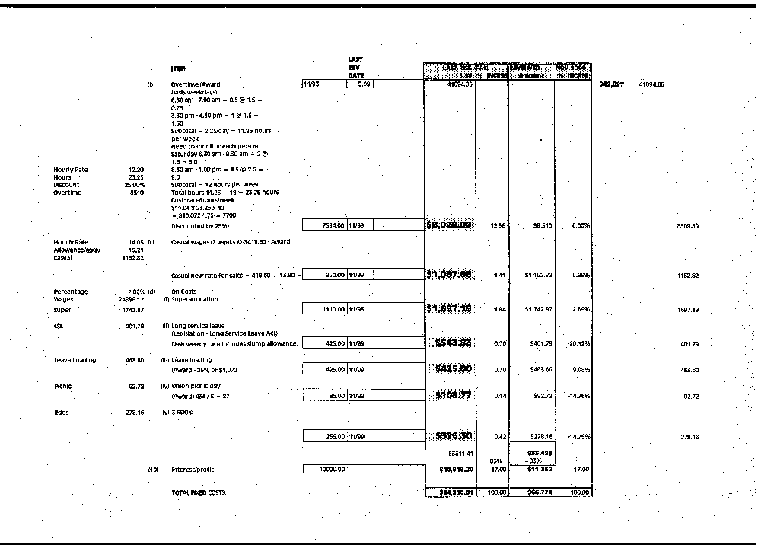

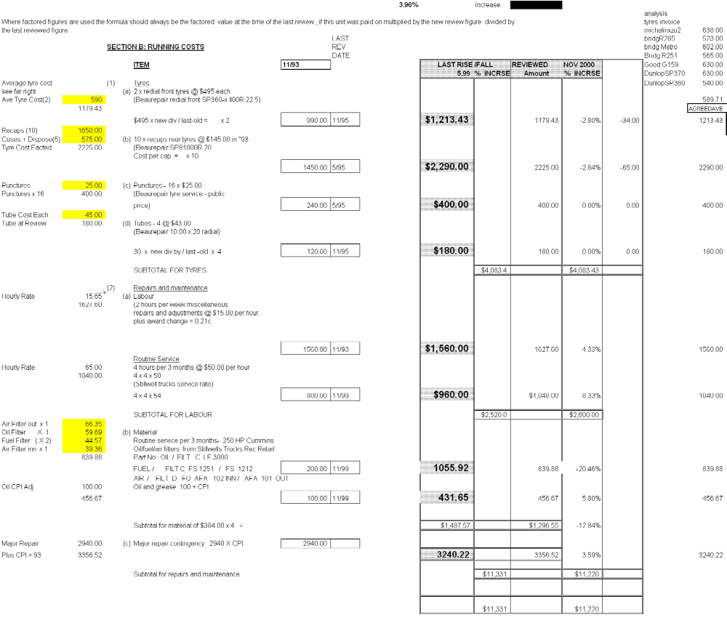

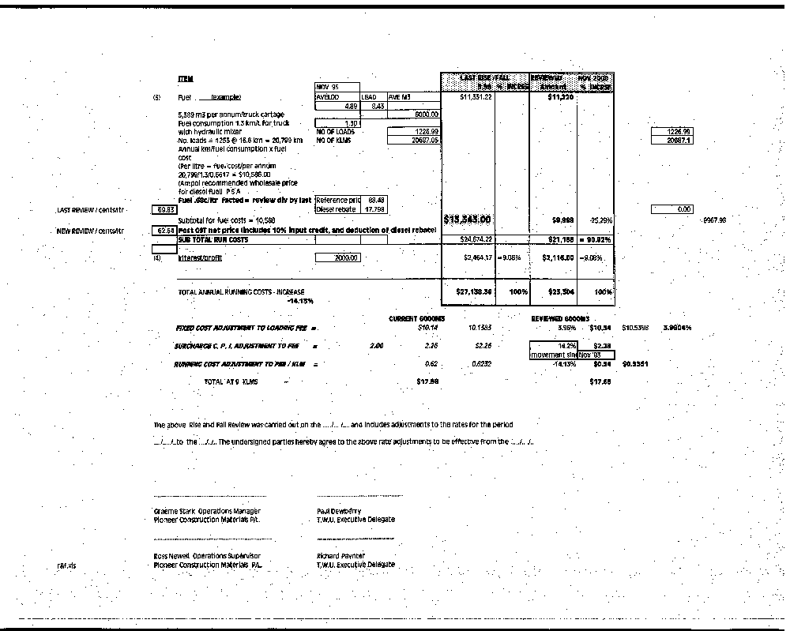

2. This variation shall take effect on and from 1 July 2000.

R. J. PETERSON J.

____________________

Printed by the authority of the Industrial Registrar.

